Ultra-Low Contrast Imaging and PCI
Minimizing contrast volume in angiography and PCI.
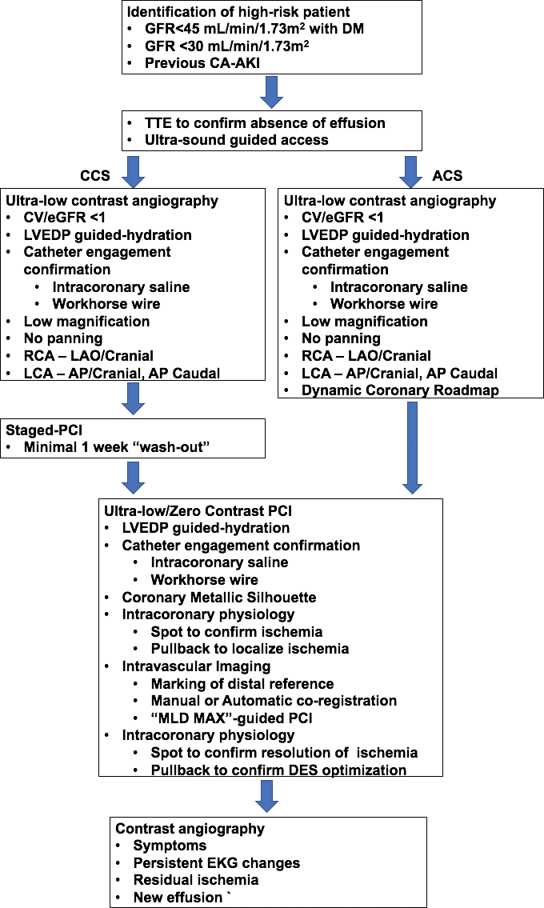By Ziad A. Ali, MD, DPhil
M

inimizing the contrast exposure and possibly using the least nephrotoxic contrast are critical in angiography and percutaneous coronary intervention (PCI) in patients with
pre-existing chronic kidney disease (CKD). Multiple exposures, especially within a short period of time (24-72 hours) can increase the risk of contrast-asso- ciated acute kidney injury (CA-AKI)1 and should be
avoided. We have established a strategy for “ultra-low” contrast angiography (ULCA) at St. Francis Hospital & Heart Center (Figure 1).

HYDRATION
It is firmly established that intravenous volume hydration reduces the incidence of CA-AKI. By expand- ing plasma volume, hydration reduces the contrast concentration and increases renal blood flow and tubular urine, reducing contrast retention and thereby its direct toxic effect.1 To achieve optimal hydration without increasing the risk of pulmonary edema, left ventricular end-diastolic pressure (LVEDP)–guided hydration has become the preferred method based on the results of the POSEIDON trial.2 It should be noted that in this study, the mean baseline serum creatinine was 1.4 mg/dL, with a mean estimated glomerular filtra- tion rate (eGFR) of 47.5 mL/min. While the benefits of intravenous hydration can probably be extrapolated to more advanced stages of CKD (stages 4 and 5), further studies are needed to establish whether hydration alone would have a similar impact on the rates of CA-AKI in this higher-risk group of patients. We have shown previ- ously that in patients with eGFR < 30 mL/min/1.73m2,

volume status cannot be predicted by clinical exami- nation, and that pre-emptive hydration may lead to potentially hazardous volume overload and resultant pulmonary edema.3 As a result, we do not suggest pre- hydration and base hydration solely on intraprocedural LVEDP, implementing the POSEIDON protocol at half the infusion rates.
Figure 1. Pathway for ULCA and ultra-low or zero-contrast PCI. ACS, acute coronary syndrome; CCS, chronic coronary syndrome; CV, contrast volume; DES, drug-eluting stent; DM, diabetes mellitus; EKG, electrocardiogram; LCA, left coronary artery; MAX, Medial dissection, Apposition, eXpan- sion; MLD, morphology, length, diameter; RCA, right coro- nary artery; TTE, transthoracic echocardiogram.

CATHETER ENGAGEMENT
Pre-empted by LVEDP-guided intraprocedural hydra- tion, for ULCA, contrast volume should be limited to a maximum contrast volume/eGFR ratio < 1.4 Both we and others have validated contrast volume/eGFR as a measure of adverse events as a result of exposure to radiocontrast, with contrast volume/eGFR > 1 exponentially increasing the risk of CA-AKI in late-stage CKD.5 As part of a ULCA strategy, two techniques can be used to confirm catheter engagement in the coronary. First, when the operator believes that the catheter is fully engaged, injection of 5 to 10 mL of saline is used to induce repolarization changes on electrocardiographic monitoring. The catheterization lab staff should be warned about repolarization abnormalities to prevent misinterpretation of acute ischemia (Figure 2). If, after multiple attempts, repolarization abnormalities cannot be determined, a Tuohy-Borst adapter is connect- ed to the diagnostic catheter, analogous to attachment
to a guide catheter, and, after heparinization, the intro- duction of a workhorse coronary guidewire is repeatedly attempted (rather than “test” contrast injections) until it successfully advances into the coronary artery.

CONTRAST INJECTION
Once the catheter is engaged, meticulous techniques are used to minimize the contrast administered in a lim- ited number of angiographic projections (Figure 2), both in the native CAD4 and graft conduits.6 While a traditional manifold may be used, the ACIST CVi® Contrast Delivery System (ACIST Medical Systems) provides the advantage of controlled volume and rise settings, along with record- ings of injection volumes for record keeping. Typically,
a single left anterior oblique (LAO)/cranial projection is used to visualize the right coronary artery and its major tributary branches. In the left coronary artery, an anterior- posterior (AP)/caudal injection is used for visualization
of the left main coronary artery and the circumflex artery and its branches. This is followed by an AP/cranial injec- tion for visualization of the left anterior descending artery and its branches. A typical ULCA can be performed with
< 10 mL of contrast dye, as outlined in Figure 2. Although the ACIST CVi® Contrast Delivery System is preferred with a rapid rise time and contrast injection limited to 5 mL,
a manifold system may also be used. Using a manifold system, brisk injections of contrast, with either a 3- or
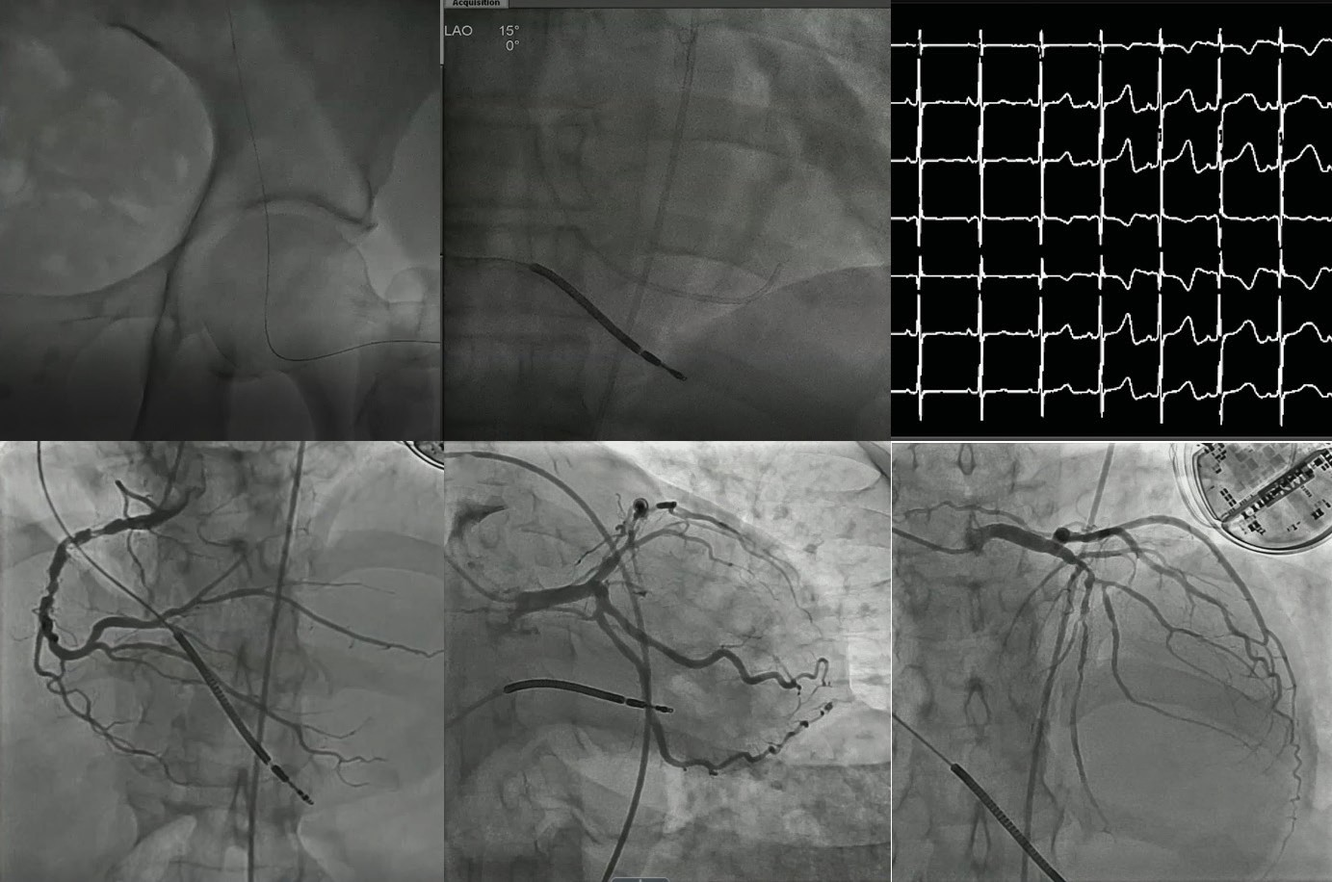5-mL syringe, can help limit injection volume. Irrespectively, cessation of injection as the vessel fully opacifies, rather than until contrast fills the distal ves- sel, is preferred for ULCA. In a single-center, non- randomized, propensity- matched observational cohort, ULCA reduced
A
B
C
D
E
F
the risk of CA-AKI and the
need for renal replace- ment therapy (RRT) compared with standard angiography in late-stage CKD during a 24-month follow-up period.7

PHYSIOLOGICAL ASSESSMENT

Figure 2. ULCA in a patient with advanced CKD and GFR 12 mL/min. If using femoral access, a combination of ultrasound to mark the common femoral bifurcation, hemostat to mark the mid-femoral head, and micropuncture access is performed (A). The LVEDP is measured to guide hydration (B). Intracoronary injection of 10 mL of 0.9% heparinized normal saline is injected into the coronary to detect repolarization changes confirming engagement. If
the catheter is engaged, transient electrocardiographic changes become evident (C). Single- view, low-magnification, non-panning angiograms of the right (LAO-cranial) (D), circumflex (AP-caudal) (E), and left anterior descending coronary arteries (AP-cranial) (F) are obtained. Total contrast volume was < 10 mL.
When angiographically ambiguous lesions are present, adjunctive tests such as coronary physiol- ogy are used to further assess lesion severity (Figure 3). The Navvus II® Rapid Exchange FFR microcatheter (ACIST

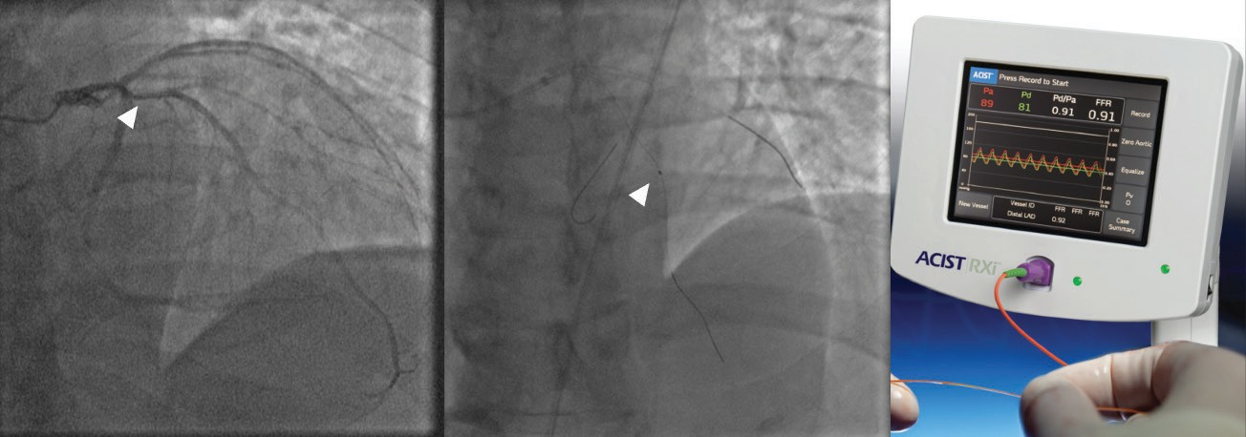
A B C
Figure 3. Ultra-low contrast invasive coronary physiology to eliminate diagnostic ambiguity. A patient with advanced CKD (GFR 8 mL/min) underwent ULCA with contrast dilution showing an ambiguous lesion in the proximal left anterior descend- ing coronary artery (arrow) (A). Invasive coronary physiology is performed with the Navvus II microcatheter (B), without con- trast guidance, confirming the absence of ischemia (C).

Medical Systems) is an elegant way to perform physi- ological assessment in ambiguous lesions because the microcatheter may be used with a standard workhorse wire, with potential safety advantages over other wire- based physiology devices, such as wire-induced dissection and inadvertent passage into small vessels.

PERCUTANEOUS CORONARY INTERVENTION
“Zero-contrast” PCI, which is typically a staged proce- dure in non-ACS patients, is a strategy for PCI without using, or drastically minimizing, contrast in late-stage CKD. The previously performed ULCA serves as the blueprint or roadmap.4 Staging the procedure allows for a reduction in the total contrast exposure, recovery of kidney function, and discussion of the risks and ben- efits of zero-contrast PCI with the patient. Previously obtained diagnostic angiograms are displayed and used
as a roadmap for guide catheter engagement and guide- wire advancement. The shapeable tips of the guidewire are typically looped whenever possible to decrease the chances of distal vessel perforation. Use of several guide- wires is recommended to generate a metallic silhouette or coronary skeleton of the target vessel and its branches (Figures 3 and 4). The procedure is then guided by intravascular imaging (ultrasound4 or optical coherence tomography with saline flush8) with or without coronary physiology. Coregistration of physiology and intracoro- nary imaging pullback with the wire silhouette allows for contrast-free localization of flow-limiting stenoses, vessel segments that require plaque preparation, optimal stent landing zones, and choosing stent size and length. After stent implantation, the same approach can be followed
to verify the results of PCI or to guide optimization, also with the use of stent enhancement tools, all without the need for contrast injections. Prespecified criteria indicat- ing procedural complications or suboptimal results are devised to guide the use of contrast to perform angiog- raphy during the zero-contrast procedure, if indicated.4 These include unresolved electrocardiogram changes
or symptoms, hemodynamic instability, failure of physi- ological parameters to improve, or the presence of a new effusion on echocardiography (Figure 1).
An initial report in 35 patients with eGFR 16 ±
8 mL/min/1.73m2 supported the feasibility and safety of this approach, resulting in preserved postprocedural kidney function in all patients and no need for RRT.4
A prospective, single-center, propensity-matched comparison with standard angiography alone showed that combined ULCA and zero-contrast PCI was associ- ated with a significant reduction in the rates of RRT within a 12-month follow-up period (hazard ratio, 0.40; 95% CI, 0.21-0.75; P = .0032).9 Given the frequent presence of severe calcification, atherectomy may be needed during zero-contrast PCI to modify the fibro- calcific plaques and optimize PCI results.10 The recent advent of intravascular lithotripsy, which is a balloon catheter-based technique, may simplify calcific plaque modification as part of zero-contrast PCI.11 The feasibil- ity of zero-contrast PCI has also been shown in complex lesions (such as chronic total occlusions12 and high-risk PCI with hemodynamic support13 or in vein grafts14).
Randomized studies are warranted to further establish the role of ULCA and zero-contrast PCI as part of the invasive management strategy for coronary artery dis- ease in late-stage CKD.

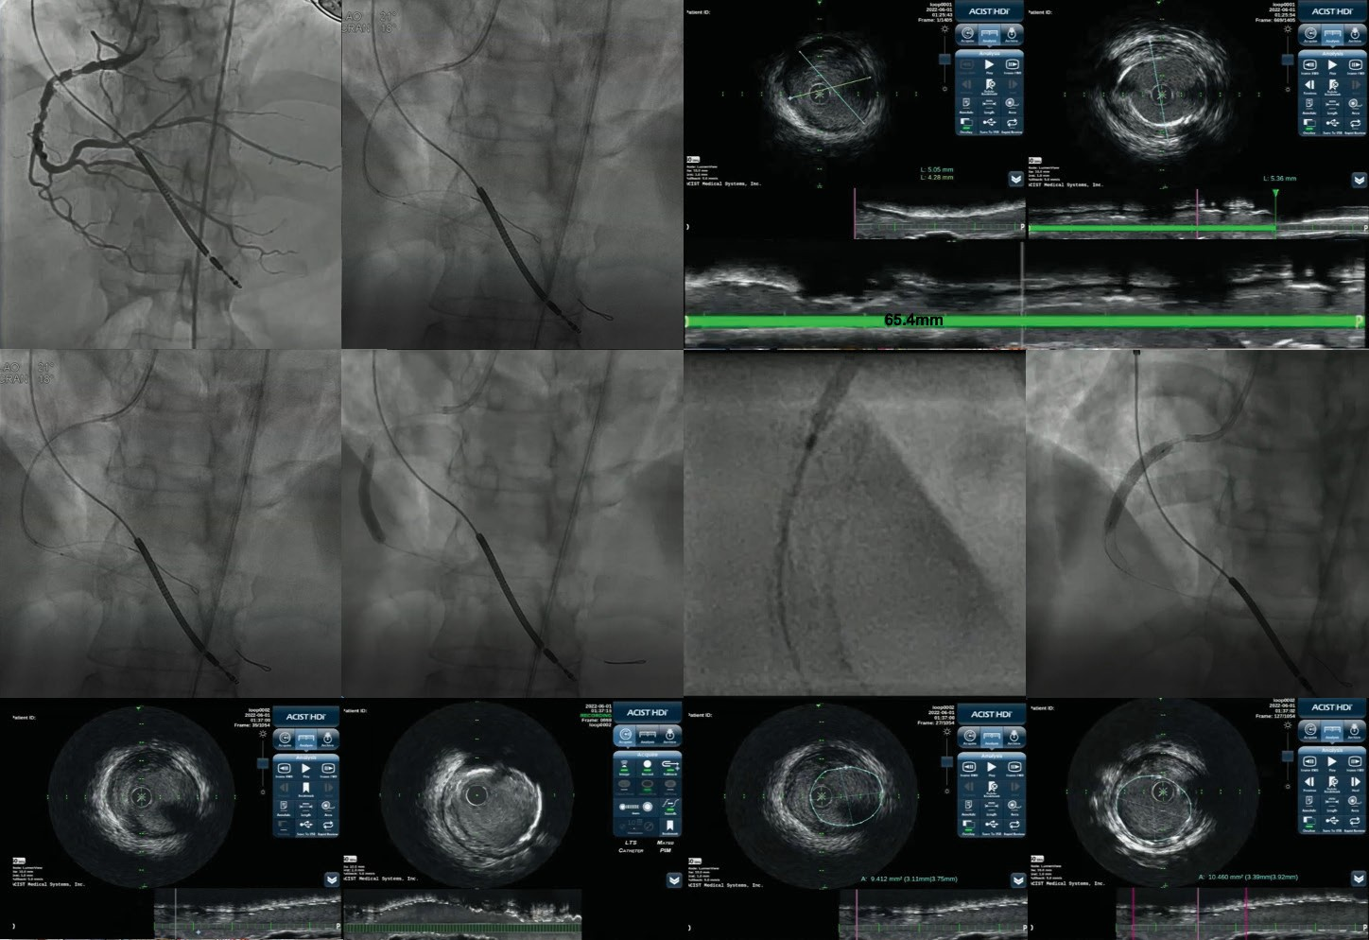
A
B
C
D
E
F
G
H
I
J
K
L
Figure 4. Zero-contrast PCI in a patient with advanced CKD. A roadmap from a previously performed ULCA of the right coronary artery with 3 mL of contrast in the LAO-cranial view is projected (A). A reference segment distal to the lesion is identified manually and marked with cine angiography (B). By coregistering the intravascular ultrasound pullback with the angiogram, reference vessel measurements are obtained at the distal reference segment, revealing a mean distal vessel size of 4.6 mm (C). Following the same approach, a proximal, disease-free segment is identified: The length of lesion measured from the distal reference to this segment (green line) is 65.4 mm and the mean proximal vessel size is 5.3 mm (D). The stent is then deployed using manual intravascular ultrasound co-registration marking (E), where the distal stent marker is aligned to the intravascular ultrasound transducer and a 4.5-mm X 38-mm drug-eluting stent is deployed (F). Given a total stent length of 65 mm, and the distal deployment of a 38-mm stent, the proximal stent is determined to be a 5-mm X 28-mm device. High-magnification cine angiography, or preferentially advanced features such as StentBoost (Philips), StentViz
(GE Healthcare), or Device Detection (Philips), are used to confirm optimal overlap (G). The proximal 5-mm X 28-mm stent is deployed (H). The distal (I) and proximal (J) stent edge were free of dissection. Stent expansion was confirmed by measuring the distal reference area (9.4 mm2) (K) and comparing it to the manually identified minimal stent area (10.4 mm2) confirming
> 100% expansion (L).

CONCLUSION
Patients at risk of CA-AKI should be carefully assessed before cardiovascular procedures that involve using con- trast media. Patients with multiple risk factors, especially those with baseline CKD, heart failure, and diabetes are at a particularly high risk of CA-AKI. Various risk scores have been proposed and tested but their routine use is hampered by inadequate validation.
Modifiable patient- and procedure-related factors should be corrected prior to angiography. At present,
intravenous hydration is the only evidence-based strat- egy for prevention of CA-AKI and normal saline is the preferred solution. The aim is to achieve optimal volume expansion without increasing the risk of pulmonary edema. Because patients with advanced CKD, particu- larly those in stage 5 CKD who are not on maintenance dialysis, may have fluid retention, intravenous hydra- tion is best initiated during the procedure after the LVEDP is measured. Principles of ULCA and staged zero- contrast PCI have been described and widely adopted.

Interventionalists ought to learn the techniques, in par- ticular the use of intravascular imaging, to perform PCI safely and effectively in patients with advanced CKD with- out compromising the residual kidney function. Finally, novel biomarkers and pharmaceutical agents targeting the pathogenic pathways involved in CA-AKI should be developed and validated in large-scale clinical trials. n

- van der Molen AJ, Reimer P, Dekkers IA, et al. Post-contrast acute kidney injury - part 1: definition, clinical features, incidence, role of contrast medium and risk factors: recommendations for updated ESUR Contrast Medium Safety Committee guidelines. Eur Radiol. 2018;28:2845-2855. doi: 10.1007/s00330-017-5246-5
- Brar SS, Aharonian V, Mansukhani P, et al. Haemodynamic-guided fluid administration for the prevention of contrast-induced acute kidney injury: the POSEIDON randomised controlled trial. Lancet. 2014;383:1814-1823. doi: 10.1016/S0140-6736(14)60689-9
- Ali ZA, Escaned J, Dudek D, et al. Strategies for renal protection in cardiovascular interventions. Korean Circ J. 2022;52:485-495. doi: 10.4070/kcj.2022.0093
- Ali ZA, Karimi Galougahi K, Nazif T, et al. Imaging- and physiology-guided percutaneous coronary intervention without contrast administration in advanced renal failure: a feasibility, safety, and outcome study. Eur Heart J. 2016;37:3090-3095. doi: 10.1093/eurheartj/ehw078
- Nyman U, Bjork J, Aspelin P, Marenzi G. Contrast medium dose-to-GFR ratio: a measure of systemic exposure to predict contrast-induced nephropathy after percutaneous coronary intervention. Acta Radiol. 2008;49:658-667. doi: 10.1080/02841850802050762
- Rahim HM, Flattery E, Gkargkoulas F, et al. Ultra-low-contrast angiography in patients with advanced chronic kidney disease and previous coronary artery bypass surgery. Coron Artery Dis. 2019;30:346-351. doi: 10.1097/ MCA.0000000000000741
- Bhatti N, Rahim H, Chen S et al. Ultra-low contrast coronary angiography in patients with advanced chronic kidney disease: feasibility and outcomes compared with conventional angiography. J Am Coll Cardiol. 2019;74(13 suppl):B30.
- Karimi Galougahi K, Zalewski A, Leon MB, et al. Optical coherence tomography-guided percutaneous coronary intervention in pre-terminal chronic kidney disease with no radio-contrast administration. Eur Heart J. 2016;37:1059. doi: 10.1093/eurheartj/ehv667
- Rahim H, Flattery E, Gkargkoulas F, et al. Clinical outcomes of imaging- and physiology-guided PCI without contrast administration in advanced renal failure. J Am Coll Cardiol. 2019;74(13 suppl):B32.
- Karimi Galougahi K, Mintz GS, Karmpaliotis D, Ali ZA. Zero-contrast percutaneous coronary intervention on calcified lesions facilitated by rotational atherectomy. Catheter Cardiovasc Interv. 2017;90:E85-E89. doi: 10.1002/ ccd.26999
- Karimi Galougahi K, Patel S, Shlofmitz RA, et al. Calcific plaque modification by acoustic shockwaves - intravas- cular lithotripsy in coronary interventions. Circ Cardiovasc Interv. 2021;14:e009354. doi: 10.1161/CIRCINTERVEN- TIONS.120.009354
- Hatem R, Finn MT, Riley RF, et al. Zero contrast retrograde chronic total occlusions percutaneous coronary intervention: a case series. Eur Heart J Case Rep. 2018;2:1-5. doi: 10.1093/ehjcr/yty036
- Madhavan MV, Prasad M, Fall KN, et al. Zero-contrast multivessel revascularization for acute coronary syn- drome in a patient with chronic kidney disease. JACC Case Rep. 2019;1:774-780. doi: 10.1016/j.jaccas.2019.11.006
- Parviz Y, Fall K, Stone GW, et al. Imaging and physiology to guide venous graft interventions without contrast administration in advanced renal failure. J Invasive Cardiol. 2017;29:E163-E165.
Ziad A. Ali, MD, DPhil
The Heart Center
DeMatteis Cardiovascular Institute St. Francis Hospital
Roslyn, New York Clinical Trials Center
Cardiovascular Research Foundation New York, New York
(516) 562-6624; ziad.ali@chsli.org Disclosures: St. Francis Hospital and Heart Center receive institutional grant support from ACIST Medical.

